**Experiment No. 2.3**

**Student Name: Rishav Kumar UID: 22MCC20039**

**Branch: MCA - CCD Section/Group: MCD-1/ Grp A**

**Semester: III Date of Performance: 15th Oct 23**

**Subject Name: Business Analytics Subject Code: 22CAH-703**

1. **Aim/Overview of the practical:**

Questions on Joins in SQL

**2. Code for practical:**

In SQL, joins are used to combine rows from two or more tables based on a related column between them. Joins allow you to retrieve data from multiple tables, and they are a fundamental concept in relational databases. There are several types of joins, but the most common ones include INNER JOIN, LEFT JOIN (or LEFT OUTER JOIN), RIGHT JOIN (or RIGHT OUTER JOIN), and FULL JOIN (or FULL OUTER JOIN). Here's a brief definition and syntax for each of these join types:

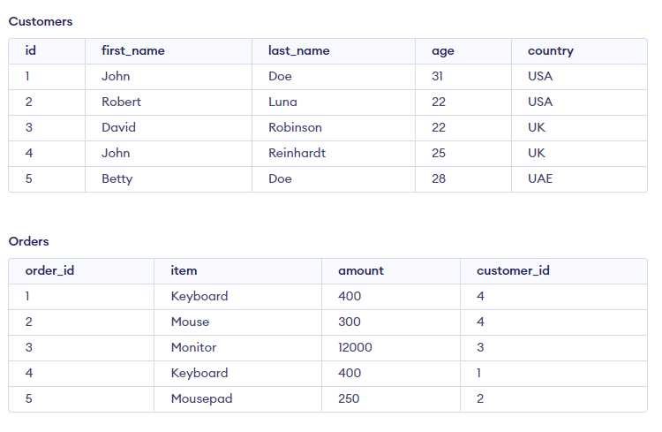

**INNER JOIN:**

**Definition:** Retrieves rows from both tables that have matching values in the specified columns, excluding rows with no matching values.

**Syntax:**

***SELECT columns FROM table1 INNER JOIN table2 ON table1.column = table2.column;***

***Example:***

***Select id, first_name, age from Customers***

***INNER JOIN Orders ON Customers.id = Orders.customer_id;***

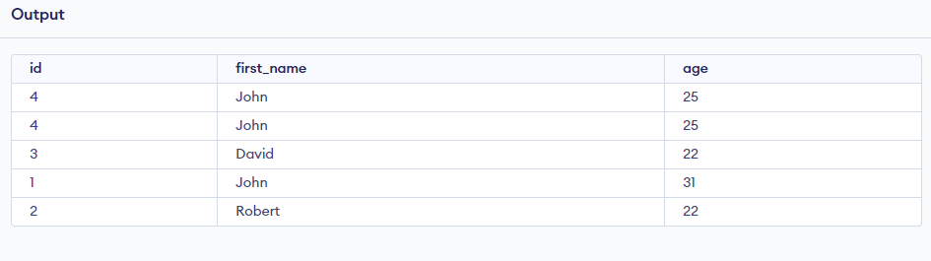

**LEFT JOIN (or LEFT OUTER JOIN):**

**Definition:** Retrieves all rows from the left table and the matching rows from the right table. If there are no matches, NULL values are returned for the columns from the right table.

**Syntax:**

***SELECT columns FROM table1 LEFT JOIN table2 ON table1.column = table2.column;***

***Example:***

***Select id, first_name, age from Customers***

***LEFT JOIN Orders ON Customers.id = Orders.customer_id;***

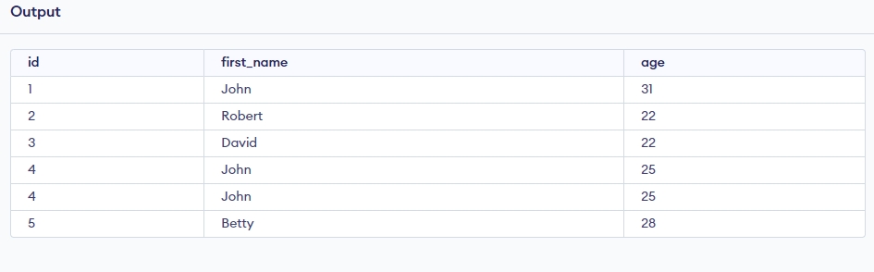

**RIGHT JOIN (or RIGHT OUTER JOIN):**

**Definition:** Retrieves all rows from the right table and the matching rows from the left table. If there are no matches, NULL values are returned for the columns from the left table.

**Syntax:**

***SELECT columns FROM table1 RIGHT JOIN table2 ON table1.column = table2.column;***

***Example:***

***Select id, first_name, age from Customers***

***Right JOIN Orders ON Customers.id = Orders.customer_id;***

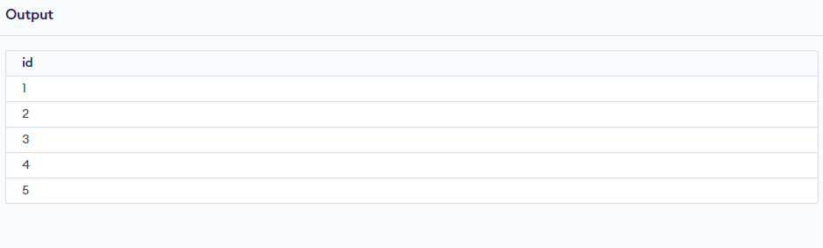

**FULL JOIN (or FULL OUTER JOIN):**

**Definition:** Retrieves all rows when there is a match in either the left or the right table. NULL values are returned for columns that don't have matches.

**Syntax:**

***SELECT columns FROM table1 FULL JOIN table2 ON table1.column = table2.column;***

***Example:***

***Select id, first_name, age from Customers***

***FULL JOIN Orders ON Customers.id = Orders.customer_id;***

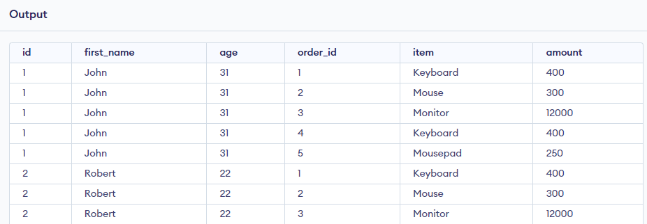

**************************************** **THE END** ***********************************************